**PART B: Micro-project Report**

**Directory Structure**

1. **Rationale:**

Directory structure is to create an organized, efficient, and logical system for storing and

managing files and directories on a computer or storage device. A well-designed directory

structure offers several benefits:

* Organization: An organized directory structure makes it easier to find and manage files. Files are grouped into directories based on their content or purpose, making it intuitive to locate specific information.
* Efficiency: A well-structured directory system promotes efficiency in file management. Users can quickly navigate to the desired location and access files without wasting time searching through cluttered or disorganized folders.
* Consistency: A consistent directory structure across an organization or system ensures that everyone follows the same organizational principles. This consistency reduces confusion and improves collaboration among team members.
* Scalability: A well-designed directory structure is scalable, meaning it can accommodate an increasing volume of files and directories without becoming unwieldy. As new data is generated, it can be easily integrated into the existing structure.
* Backup and Recovery: An organized directory structure simplifies backup and recovery processes. It's easier to back up specific directories or types of data, ensuring that critical information is protected. In case of data loss, it's also easier to recover specific files or directories.
* Access Control: Directory structures can be used to enforce access controls and permissions. By organizing files into directories with specific permissions, organizations can control who can access, modify, or delete certain data.
* Navigation: A well-structured directory hierarchy simplifies navigation, especially in command-line interfaces. Users can use relative and absolute paths to move between directories with ease, improving productivity.
* Redundancy Reduction: An organized directory structure helps reduce redundancy by ensuring that files are stored in appropriate locations. Duplicate files can be minimized, saving storage space and preventing confusion.
* Documentation: A clear directory structure can serve as documentation for users and administrators. It can provide insights into the purpose of each directory and the type of data it contains.
* Data Integrity: An organized structure can help maintain data integrity. It reduces the risk of accidental data loss or corruption by providing a clear separation of data and system files.
* File Naming Conventions: Directory structures often go hand-in-hand with file naming conventions. Consistent file naming within a well-structured directory system further enhances the ease of use and searchability of data.
* User Experience: A well-designed directory structure enhances the user experience. Users can access the information they need quickly and efficiently, leading to increased productivity and satisfaction.

1. **Course Outcomes Addressed:**
2. Install operating system and configure it.
3. Use operating system tools to perform various functions.
4. Execute process commands for performing process management operation.
5. Apply Scheduling Algorithm to calculate turnaround time and average waiting time.
6. Calculate efficiency of different memory management techniques.
7. Apply file management techniques.
8. **Literature Review:**

Before the invention of directory structures and Hierarchical System, computing and users faced several significant challenges and limitations in terms of organizing and managing files and data.

**Difficulties Before Directory Structures:**

* **Flat File Systems:** Early computing systems often used flat file systems where all files were stored in a single directory without any hierarchical structure. This led to naming conflicts, data clutter, and inefficient organization.
* **Lack of Organization:** Without a hierarchical structure, there was no effective way to categorize or organize files by type, project, or purpose. Users had to rely on unique file names to differentiate between files.
* **Data Integrity Concerns:** Flat file systems had limited mechanisms for maintaining data integrity. Data could be easily overwritten, deleted, or corrupted.
* **Data Redundancy:** Without a structured way to organize files, data redundancy was common. Users often created duplicate files or stored the same data in multiple locations.

**Solutions After the Introduction of Directory Structures:**

* **Hierarchical Organization:** Directory structures introduced a hierarchical system where files and directories were organized in a tree-like fashion. This allowed for a more logical and structured organization of data.
* **Scalability:** Directory structures made data management scalable. As data grew, additional directories and subdirectories could be created to accommodate the expanding volume of files.
* **Data Integrity:** Directory structures helped maintain data integrity by reducing the risk of accidental data overwrites, deletions, or corruption.
* **Reduced Redundancy:** The structured organization of files and directories in a hierarchy reduced data redundancy. Files could be logically placed in appropriate directories, reducing the need for duplicates.

1. **Actual Methodology Used:**

1. **Single Level Directory:**

A single-level directory structure is one of the simplest forms of organizing files on a computer or file system. In a single-level directory structure, all files are located in a single directory or folder without any subdirectories. Each file must have a unique name within that directory to avoid naming conflicts.

* Flat Hierarchy: All files are stored in a single directory without any nesting or subdirectories. This results in a flat hierarchy where all files are at the same level.
* File Naming: To prevent naming conflicts, each file in the directory must have a unique name. Duplicate names can cause issues when trying to access or manage files.

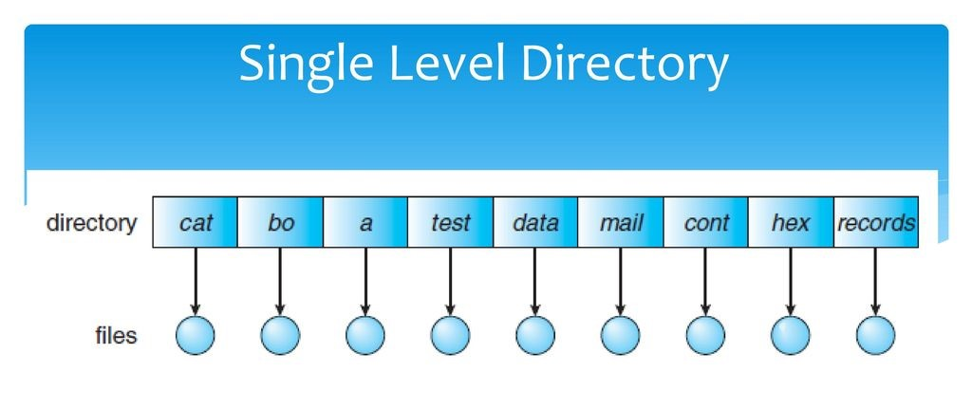

1. **Two Level Directory:**

A two-level directory structure, also known as a two-tier or two-level hierarchy, is an organizational system for files and directories in which there are two main levels of categorization. This structure is a step up in complexity from a single-level directory structure and offers more organization and categorization options. Here's an overview of a two-level directory structure:

* Top-Level Directory (Level 1): In a two-level directory structure, the top-level directory is the primary level of organization. It serves as a high-level category or container for grouping related files and subdirectories. Each top-level directory represents a distinct category or project.
* Subdirectories (Level 2): Under each top-level directory, there are subdirectories that further categorize or organize files. Subdirectories are used to group files with similar characteristics, functions, or purposes within the context of the top-level category.

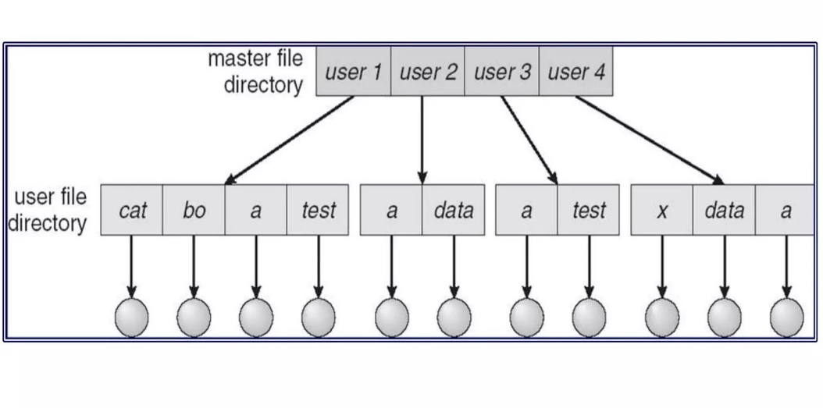

1. **Tree Structure Directory:**

A tree structure directory, often referred to as a tree directory structure or hierarchical directory structure, is a method of organizing files and directories on a computer or file system in a hierarchical, tree-like fashion. In this structure, directories can contain both files and subdirectories, allowing for a more complex and organized organization of data.

* Root Directory: At the top of the hierarchy is the root directory. It serves as the starting point and is the highest-level directory in the tree structure. In Unix-based systems, it is represented by a forward slash ("/"), and in Windows, it is represented by a drive letter (e.g., "C:").
* Branches and Subdirectories: Below the root directory, the tree structure branches out into subdirectories. Each subdirectory can contain files and additional subdirectories. Subdirectories are used to further categorize and organize data.
* Leaves and Files: At the end of each branch are the leaves of the tree, which represent individual files. These files can be documents, images, programs, or any other type of data.
* Hierarchical Organization: The tree structure allows for a hierarchical organization of data. Subdirectories can have their own subdirectories, creating a multi-level hierarchy for organizing files and data logically.
* Path: Each file and directory within the tree structure has a unique path that specifies its location within the hierarchy. Paths can be absolute (specifying the full path from the root) or relative (specifying the path relative to the current directory).

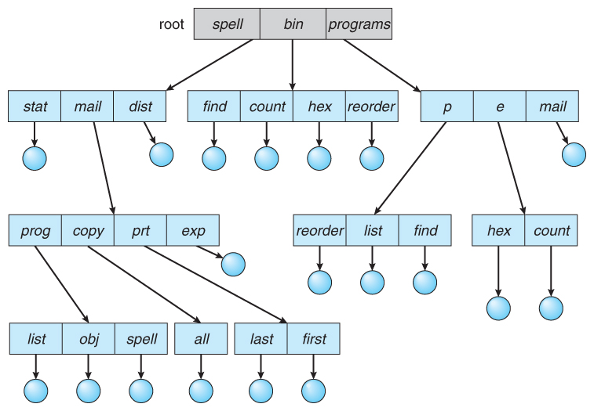

1. **Acyclic-Graph Directory:**

An acyclic graph directory, often referred to as a directed acyclic graph (DAG) directory structure, is an advanced method of organizing files and directories on a computer or file system. In this structure, directories and files are organized as nodes in a directed acyclic graph, where each node represents a file or directory, and the edges represent relationships or links between them. The key characteristic of an acyclic graph directory is that it forbids cycles or loops within the structure, ensuring that there are no circular references.

* Node-Based Structure: In an acyclic graph directory structure, files and directories are represented as nodes in a graph. Each node corresponds to a specific file or directory, and these nodes are interconnected by directed edges.
* Directed Edges: Directed edges in the graph represent relationships between nodes. These relationships can signify various types of associations, such as containment (a directory contains files or subdirectories), symbolic links (a reference to another node), or other custom relationships.
* No Cycles: The fundamental constraint of an acyclic graph structure is that it must be acyclic, meaning there are no cycles or loops within the graph. In other words, you cannot traverse a series of edges and return to the same node through a circular path.
* Navigation: Users can navigate through the tree structure by moving up and down the hierarchy. Common commands for navigation in command-line interfaces include "cd" (change directory) and "pwd" (print working directory).

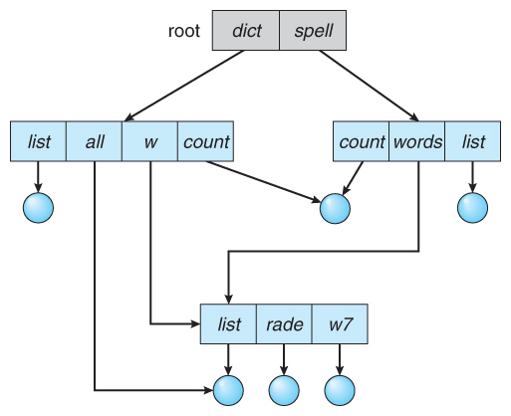

1. **General Graph Directory:**

A general graph directory, also known as a graph-based directory structure or graph directory system, is an advanced method of organizing files and directories on a computer or file system. Unlike traditional hierarchical directory structures (tree structures), where files and directories are organized in a strict parent-child relationship, a general graph directory allows for more complex relationships between files and directories by representing them as nodes and using arbitrary edges to define connections.

* Node-Based Structure: In a general graph directory, files and directories are represented as nodes in a graph. Each node corresponds to a specific file or directory, and these nodes are interconnected by edges to represent relationships between them.
* Edges and Relationships: The key feature of a general graph directory is the ability to define custom relationships between files and directories using edges. These relationships can be more flexible and expressive than the strict containment hierarchy seen in tree structures.
* Complex Relationships: General graph directories allow for complex relationships beyond the simple parent-child hierarchy. Files and directories can be linked together in various ways, such as references, associations, dependencies, and more.
* Navigation: Navigating through a general graph directory typically involves traversing the graph using graph traversal algorithms such as depth-first search (DFS) or breadth-first search (BFS) to explore the relationships between nodes.

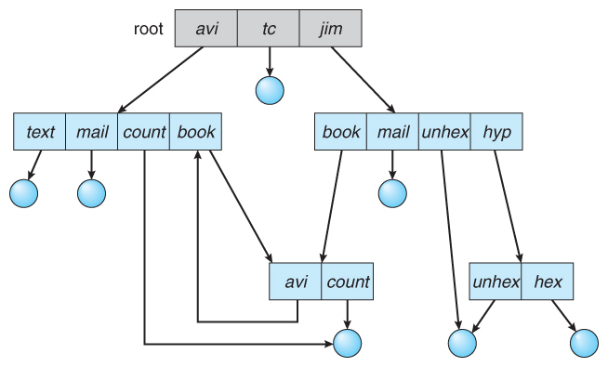

1. **Actual Resources Used:**

|  |  |  |  |
| --- | --- | --- | --- |
| Sr.  No. | Name of Resource/Material | Specifications | Qty |
| 1. | Computer / Laptop | **OS :** Windows | 1 |
| 2 | Reference | Operating system book by  TechNeo publications | 1 |

1. **Skills Developed:**

Through this project Directory Structure we got to know about various types of Directory

Structures like single level, two level, tree level, Acyclic graph, general graph directories

and all information about it. By this we get to know that these structures are very

important to organise, managing file and directories in an efficient hierarchy structure. We

learned that without directory structure it is very difficult to manage files and store in

computer system causes it to have naming conflicts, data redundancy and scalability.

Having this difficulties lead us to(Through which we) learned the concept of directory

structure and helps us to manage store file without any difficulties.

1. **Application of this Micro-Project:**

Directory structures have numerous applications across various fields and industries. They

provide an organized framework for managing and accessing files and data efficiently.

**Operating Systems:** Directory structures are fundamental components of operating

Systems like Windows, macOS, and Linux, serving as the primary means of organizing

files and directories.

**File Management:** Directory structures are used to organize and manage files on personal

computers, servers, and other storage devices. They make it easy to locate and access

specific files.

**Software Development:** Developers use directory structures to organize source code,

libraries, configuration files, and project assets. Proper organization is essential for

collaboration and code management.

1. **Area of Future Improvement:**

Directory Structures have evolved significantly over the years and are well-established for

organizing files and data, there are still areas in which they can be improved to better meet

the changing needs of users and technology.

Semantic Organization: Enhancing directory structures with semantic capabilities could

enable automatic tagging, categorization, and context-aware organization of files. This

would make it easier to find and manage files based on their content and meaning rather

than relying solely on file names and folder locations.

Machine Learning Integration: Incorporating machine learning and AI algorithms into

directory structures could enable features like automatic file classification, predictive

organization, and intelligent search based on user behaviour and preferences.

Dynamic Hierarchies: Future directory structures could support dynamic hierarchies that

adapt to user needs and workflows. This could involve the ability to create temporary or

virtual directories that provide customized views of files based on context.